1. **Read Total profit of all months and show it using a line plot.**

Total profit data provided for each month. Generated line plot must include the following properties: –

* X label name = Month Number
* Y label name = Total profit

**The Graph should look like as below:**

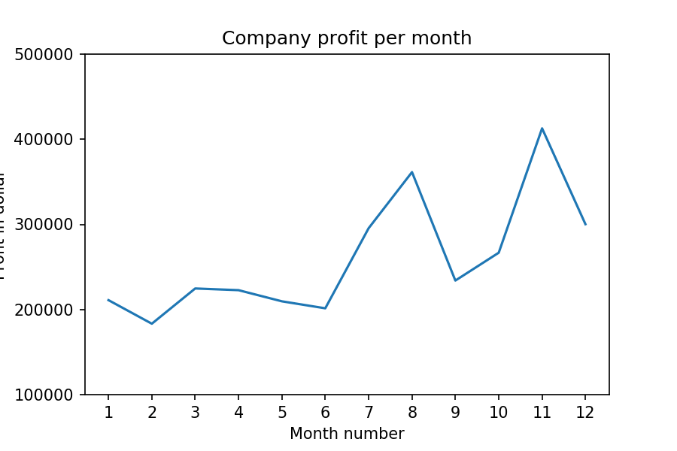

**Solution:**

import pandas as pd  
import matplotlib.pyplot as plt  
  
df = pd.read_csv('company_sales_data.csv')  
profitList = df['total_profit'].tolist()  
monthList = df['month_number'].tolist()  
plt.plot(monthList, profitList, label='Month-wise Profit data of last year')  
plt.xlabel('Month number')  
plt.ylabel('Profit in dollar')  
plt.xticks(monthList)  
plt.title('Company profit per month')  
plt.yticks([100000, 200000, 300000, 400000, 500000])  
plt.show()

1. **Get total profit of all months and show line plot with the following Style properties**

Generated line plot must include following Style properties: –

* Line Style dotted and Line-color should be red
* Show legend at the lower right location.
* X label name = Month Number
* Y label name = Sold units number
* Add a circle marker.
* Line marker color as read
* Line width should be 3

The line plot graph should look like this.

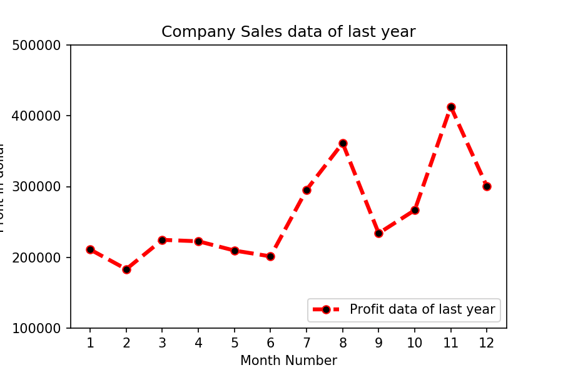

**Solution:**

import pandas as pd  
import matplotlib.pyplot as plt  
  
df = pd.read_csv('company_sales_data.csv')  
profitList = df['total_profit'].tolist()  
monthList = df['month_number'].tolist()  
  
plt.plot(monthList, profitList, label='Profit data of last year',  
 color='r', marker='o', markerfacecolor='k',  
 linestyle='--', linewidth=3)  
  
plt.xlabel('Month Number')  
plt.ylabel('Profit in dollar')  
plt.legend(loc='lower right')  
plt.title('Company Sales data of last year')  
plt.xticks(monthList)  
plt.yticks([100000, 200000, 300000, 400000, 500000])  
plt.show()

### **Read all product sales data and show it using a multiline plot**

Display the number of units sold per month for each product using multiline plots. (i.e., Separate Plotline for each product).

The graph should look like this.

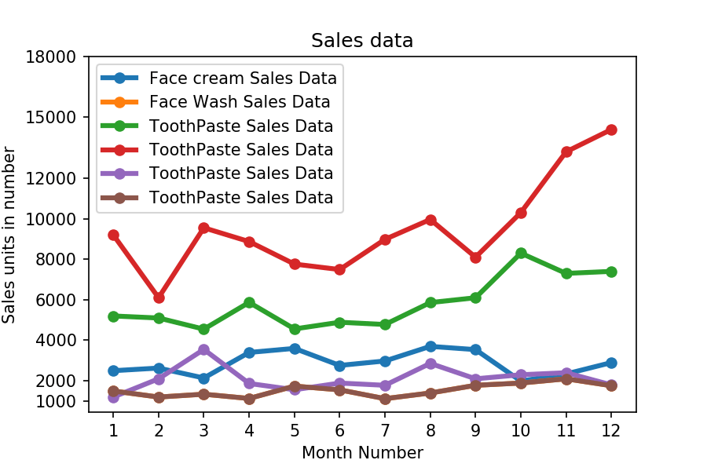

**Solution:**

import pandas as pd  
import matplotlib.pyplot as plt  
  
df = pd.read_csv('company_sales_data.csv')  
monthList = df ['month_number'].tolist()  
faceCremSalesData = df ['facecream'].tolist()  
faceWashSalesData = df ['facewash'].tolist()  
toothPasteSalesData = df ['toothpaste'].tolist()  
bathingsoapSalesData = df ['bathingsoap'].tolist()  
shampooSalesData = df ['shampoo'].tolist()  
moisturizerSalesData = df ['moisturizer'].tolist()  
  
plt.plot(monthList, faceCremSalesData, label = 'Face cream Sales Data', marker='o', linewidth=3)  
plt.plot(monthList, faceWashSalesData, label = 'Face Wash Sales Data', marker='o', linewidth=3)  
plt.plot(monthList, toothPasteSalesData, label = 'ToothPaste Sales Data', marker='o', linewidth=3)  
plt.plot(monthList, bathingsoapSalesData, label = 'ToothPaste Sales Data', marker='o', linewidth=3)  
plt.plot(monthList, shampooSalesData, label = 'ToothPaste Sales Data', marker='o', linewidth=3)  
plt.plot(monthList, moisturizerSalesData, label = 'ToothPaste Sales Data', marker='o', linewidth=3)  
  
plt.xlabel('Month Number')  
plt.ylabel('Sales units in number')  
plt.legend(loc='upper left')  
plt.xticks(monthList)  
plt.yticks([1000, 2000, 4000, 6000, 8000, 10000, 12000, 15000, 18000])  
plt.title('Sales data')  
plt.show()

1. **Read toothpaste sales data of each month and show it using a scatter plot**

**Also, add a grid in the plot. gridline style should “–“.**

**The scatter plot should look like this.**

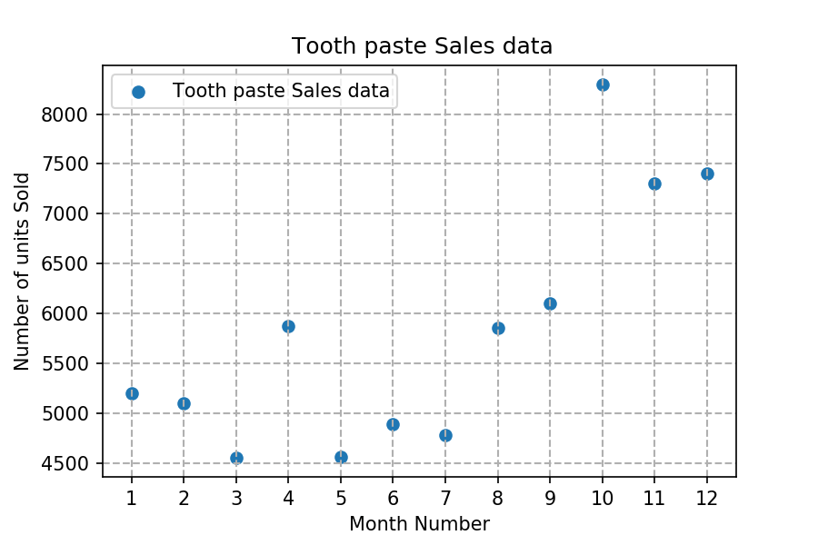

**Solution:**

import pandas as pd  
import matplotlib.pyplot as plt  
  
df = pd.read_csv('company_sales_data.csv')  
monthList = df ['month_number'].tolist()  
toothPasteSalesData = df ['toothpaste'].tolist()  
plt.scatter(monthList, toothPasteSalesData, label = 'Tooth paste Sales data')  
plt.xlabel('Month Number')  
plt.ylabel('Number of units Sold')  
plt.legend(loc='upper left')  
plt.title(' Tooth paste Sales data')  
plt.xticks(monthList)  
plt.grid(True, linewidth= 1, linestyle="--")  
plt.show()

